Emerson Health Community Benefits Grant
Appendices

Appendix A: Emerson Health Service Area Map
Appendix B: SMART Goals
Appendix C: Sample Budget Form and Justification

APPENDIX A
EMERSON HEALTH SERVICE AREA MAP

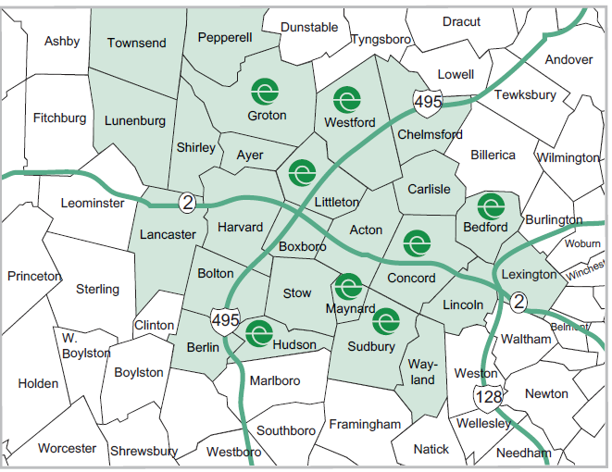

APPENDIX B

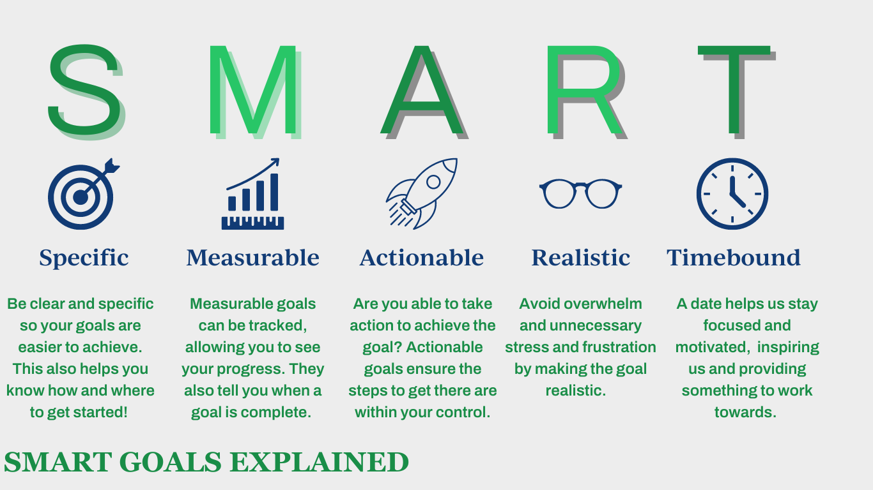

APPENDIX C

SAMPLE BUDGET FORM AND JUSTIFICATION

Budget Form SAMPLE
Itemize all expenses and summarize all revenue and in-kind support for the project.

Line Item | Amount requested in application | IN-KIND and OTHER  SOURCES of funding  (Source and Amount)  In-kind designates donated goods or services. | TOTAL PROJECT COSTS
Staff  (Indicate number of hours to be applied to this project and hourly rate.) | Activity coordinator: $37/hr x 50 hours= $1850  Executive Director= $50/hr x 25 hours=$1250 |  | $3,100
Contract Services  (hourly rate, number of hours.) | Exercise teacher: $20/hr x 25 hours=$500 |  | $500
Supplies/Equipment | Books for students: $450  Marketing costs: $250 |  | $700
Other Expenses | Music subscription for exercise classes: $90 |  | $100
TOTAL | $4,390 |  | $4,400

JUSTIFICATION SAMPLE
The budget justification must explain the relevant details of each line item.
Justification should not include program details that are not identified elsewhere in your proposal.
If needed, the budget justification may use up to two (2) additional pages.
The activity coordinator will be the primary staff overseeing the program spending 50 hours planning, conducting outreach and follow-up. The executive director will provide oversite and manage the budget and supplies with 25 hours. The program will hire an exercise teacher to conduct the classes, the hourly rate is $20, and will cover the 10-week program; the additional 5 hours are for preparation time. The Center will be covering the music costs for the class with a 6 month premium Spotify subscription. The class will provide books to 30 participants at $15 per book. Marketing costs to promote the program will include printing flyers and mailing them, as well as online promotion.

